Deep Learning Assignment 1
Course: CS6886W – Systems Engineering for Deep Learning
Student: Prateek Maheshwari
Roll Number: CS25M525

Question 1a) Prepare CIFAR-10 with proper normalization and data augmentation. Specify the transforms used.
Ans. The training transformations used in the supplied implementation are:
- Random Crop: Crops a 32 × 32 image after adding four pixels of reflective padding.
- Random Horizontal Flip: Randomly flips images horizontally with probability 0.5.
- Color Jitter: Applies small changes to brightness, contrast, and saturation.
- To Tensor: Converts the image into a tensor with values scaled to the range [0, 1].
- Normalize: Standardizes each colour channel using its mean and standard deviation.
The mean and standard deviation are calculated from the training dataset. For validation and testing, random augmentation is not applied; the same normalization statistics are used.
Output:
Using mean and standard deviation as follows.
CIFAR-10 Mean: [0.4914, 0.4822, 0.4465]
CIFAR-10 Std: [0.2457, 0.2422, 0.2598]
Code for Mean & STD calculation is in main.py

b) Train the model with one chosen configuration (preferably the one that gives the best test accuracy).
Ans. Hyper parameters for an optimized training of model are as follows:
- Mean and standard normalization
- Transforms such as random flip, random horizontal flip, Color jitter.
- Activation function: SiLU
- Optimizer: Adam
- Epochs: 50
- Learning Rate: 0.001
Best Model Test Accuracy: 85.93% and Test Loss: 0.583395172

c) Report the final test top-1 accuracy and include loss/accuracy curves.
Ans. Top Test Top-1 Accuracy is of 85.93% with following hyper parameters
- Activation function: SiLU
- Optimization: Adam
- Learning Rate: 0.001
- Epochs: 50
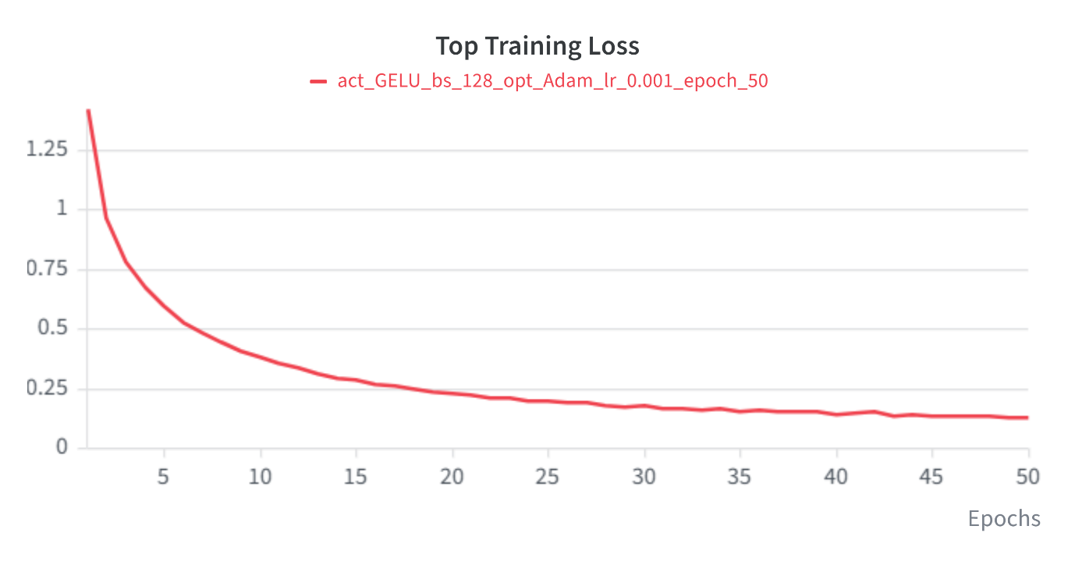
Figure: Top Training Loss Curve for GELU Adam Model

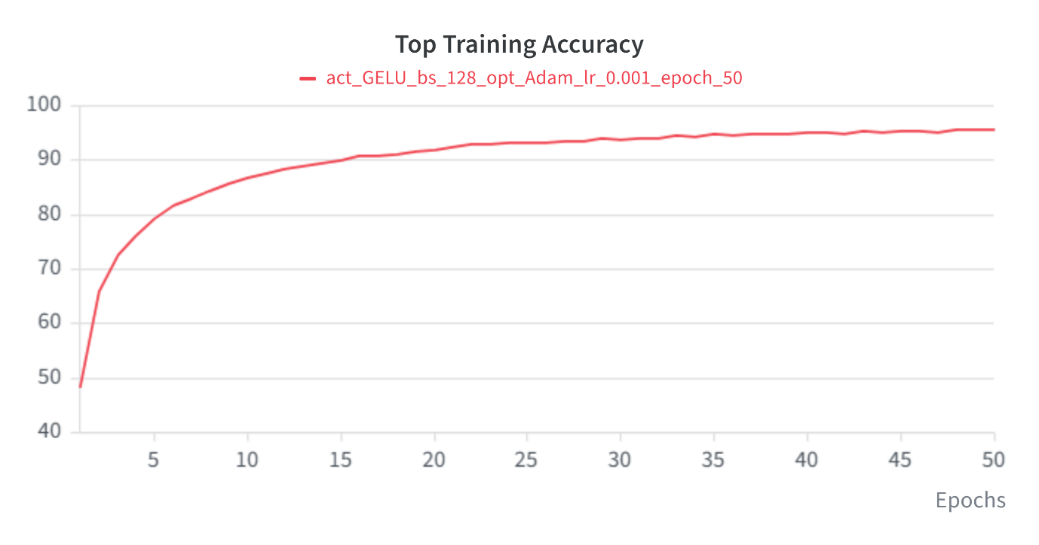
Figure: Top Training Accuracy Plot for GELU Adam Model

Question 2. a) Vary the activation function. Use different activations such as ReLU, Sigmoid, Tanh, SiLU, GELU. Describe how model performance changes when the activation function is varied.
Ans. The following results were obtained by evaluating the Adam optimizer with different activation functions. All experiments were conducted for 50 epochs, with a learning rate of 0.001 and a batch size of 128. The normalization and data augmentation techniques specified in Question 1(a) were applied consistently across all experiments.

Comparison Table for each Activation against Adam optimizer
Sno | Activation | Optimizer | Training Accuracy (%) | Training  Loss | Validation Accuracy (%) | Validation Loss | Testing Accuracy (%) | Testing  Loss
1 | Tanh | Adam | 80.12889 | 0.560484 | 79.82 | 0.589936 | 78.18 | 0.629432
2 | SiLU | Adam | 95.16667 | 0.143329 | 85.02 | 0.626606 | 85.93 | 0.583395
3 | Sigmoid | Adam | 89.60889 | 0.294304 | 79.22 | 0.666137 | 78.78 | 0.685982
4 | Relu | Adam | 93.20889 | 0.196722 | 83.7 | 0.601467 | 84.85 | 0.526434
5 | GELU | Adam | 95.74444 | 0.126518 | 85.44 | 0.626079 | 85.54 | 0.572821

Five activation functions are considered: ReLU, Sigmoid, Tanh, SiLU, and GELU. The same model architecture and comparable training settings should be used for each experiment so that the effect of the activation function can be evaluated.
Observations
- Tanh had the lowest training accuracy (80.13%), but its train, validation and test scores are all close together (about 78 to 80%). It is learning slowly or underfitting, with almost no overfitting. Its test accuracy is the lowest of the five.
- Sigmoid fits the training data better than Tanh (89.61%), yet validation and test accuracy are about 79%. That is a gap of roughly 10 points, and it has the highest test loss (0.686). Sigmoid’s saturating gradients slow learning, and it still generalizes poorly.
- ReLU reaches 93.21% training accuracy and 84.85% test accuracy. It has the lowest test loss (0.526) and a smaller train-validation gap than SiLU or GELU, so its predictions are the best calibrated and most stable of the group.
- SiLU and GELU perform almost identically. They have the highest training accuracy (about 95%) and validation accuracy (about 85%). SiLU has the best test accuracy (85.93%), with GELU close behind (85.54%). Both have the lowest training losses, but their validation losses (about 0.626) are higher than ReLU’s, and the gap between training loss (0.13 to 0.14) and validation loss shows they overfit more.
Conclusion
- The choice of activation function noticeably affects both learning ability and generalization. SiLU and GELU are the best choices for this task, giving the highest accuracy, with ReLU a close and simpler alternative that has the lowest test loss. Sigmoid and Tanh are not suitable here because of their saturation and weaker performance.

b) Vary the optimizer. Use different optimizers such as SGD, Nesterov-SGD, Adam, Adagrad, RMSprop, Nadam. Explain how each optimizer affects convergence and how they differ from one another.
Ans. The following results were obtained by evaluating different optimizers while keeping the SiLU activation function fixed. All experiments were conducted for 50 epochs, with a learning rate of 0.001 and a batch size of 128. The normalization and data augmentation techniques specified in Question 1(a) were applied consistently across all experiments.
Sno | Activation | Optimization | Training Accuracy  (%) | Training  Loss | Validation Accuracy  (%) | Validation Loss | Testing Accuracy  (%) | Testing  Loss
1 | SiLU | SGD | 70.29333 | 0.838301 | 71.72 | 0.796868 | 72.66 | 0.790446
2 | SiLU | RMSprop | 94.65556 | 0.163735 | 83.72 | 0.650301 | 84.95 | 0.612453
3 | SiLU | Nesterov-SGD | 71.62444 | 0.806101 | 72.74 | 0.782375 | 73.38 | 0.769352
4 | SiLU | NAdam | 95.42889 | 0.138707 | 85.22 | 0.664551 | 85.11 | 0.615187
5 | SiLU | Adam | 95.16667 | 0.143329 | 85.02 | 0.626606 | 85.93 | 0.583395
6 | SiLU | Adagrad | 68.16667 | 0.900355 | 69.58 | 0.874247 | 69.86 | 0.864354
Comparison Table for SiLU Activation against each Optimizer

- SGD: Uses one fixed learning rate for all weights, so it converges slowly and underfits (about 70% accuracy).
- Nesterov-SGD: Adds momentum with a look-ahead step, giving slightly faster and smoother convergence than SGD (+0.7% test accuracy), but it still lags far behind the adaptive methods.
- Adagrad: Adapts the learning rate per weight, but it accumulates all past squared gradients, so the effective learning rate keeps shrinking. Learning stalls early, and it ends up the weakest (69.86% test accuracy, highest loss 0.864).
- RMSprop: Uses a moving average of squared gradients instead of a full sum, so the learning rate doesn’t decay to zero. It converges fast (about 95% training accuracy).
- Adam: Combines momentum with RMSprop-style scaling. It converges fast and generalizes best, with the highest test accuracy (85.93%) and lowest test loss (0.583).
- NAdam: Adam with Nesterov momentum. It has the best training and validation accuracy, but its test accuracy is slightly below Adam’s.
Conclusion
The choice of optimizer strongly affects convergence and final performance for this model with SiLU activation.
- Adaptive optimizers perform best. Adam (85.93% test accuracy, loss 0.583), NAdam (85.11%) and RMSprop (84.95%) converge quickly, reaching about 95% training accuracy and 84 to 86% test accuracy.
- Adam is the best overall choice. It has the highest test accuracy and lowest test loss. NAdam and RMSprop are close behind, and the differences among the three (under 1%) may be within random variation.
- SGD, Nesterov-SGD and Adagrad perform poorly. They reached only 70 to 73% test accuracy because they converge slowly and underfit within the same training budget. Adagrad was the weakest (69.86%) because its learning rate keeps shrinking as squared gradients accumulate.
- Momentum helps only slightly. Nesterov-SGD improved on plain SGD by just 0.7%, so adaptive learning rates matter more than momentum alone.
Overall, Adam with SiLU is the best configuration for this task. The SGD-family and Adagrad results likely reflect under-tuning rather than a fundamental weakness, so a higher learning rate, a schedule or more epochs could narrow the gap.

Comparison Table for each Activation Function against each Optimizer:
Sno | Activation  Function | Optimizer | Training  Accuracy (%) | Validation  Accuracy (%) | Test  Accuracy (%)
1 | Tanh | SGD | 75.32 | 77.54 | 77.11
2 | Tanh | RMSprop | 77.3 | 75.48 | 76.43
3 | Tanh | Nesterov-SGD | 75.80222 | 77.06 | 77.4
4 | Tanh | NAdam | 80.93556 | 80.64 | 79.69
5 | Tanh | Adam | 80.12889 | 79.82 | 78.18
6 | Tanh | Adagrad | 72.19778 | 73.4 | 74.64
7 | SiLU | SGD | 70.29333 | 71.72 | 72.66
8 | SiLU | RMSprop | 94.65556 | 83.72 | 84.95
9 | SiLU | Nesterov-SGD | 71.62444 | 72.74 | 73.38
10 | SiLU | NAdam | 95.42889 | 85.22 | 85.11
11 | SiLU | Adam | 95.16667 | 85.02 | 85.93
12 | SiLU | Adagrad | 68.16667 | 69.58 | 69.86
13 | Sigmoid | SGD | 10.11778 | 10.28 | 10
14 | Sigmoid | RMSprop | 9.824444 | 9.28 | 10
15 | Sigmoid | Nesterov-SGD | 10.24444 | 10.28 | 10
16 | Sigmoid | NAdam | 90.48444 | 78.28 | 78.23
17 | Sigmoid | Adam | 89.60889 | 79.22 | 78.78
18 | Sigmoid | Adagrad | 37.76 | 39.94 | 41.21
19 | Relu | SGD | 77.28 | 77.02 | 77.79
20 | Relu | RMSprop | 91.78667 | 82.36 | 83.3
21 | Relu | Nesterov-SGD | 77.72222 | 77.46 | 78.61
22 | Relu | NAdam | 93.96444 | 84.44 | 84.77
23 | Relu | Adam | 93.20889 | 83.7 | 84.85
24 | Relu | Adagrad | 68.78222 | 70.82 | 71.56
25 | GELU | SGD | 74.85111 | 74.58 | 76.17
26 | GELU | RMSprop | 94.02667 | 84.34 | 84.38
27 | GELU | Nesterov-SGD | 75.76444 | 75.82 | 77.19
28 | GELU | NAdam | 95.91778 | 86.02 | 85.1
29 | GELU | Adam | 95.74444 | 85.44 | 85.54
30 | GELU | Adagrad | 70.78222 | 72.28 | 72.26
Note: Highest Accuracies are marked in bold and italics

Best Accuracy Matrix
Sno | Accuracy | Model Description
1 | Training
  Activation | GELU
  Optimizer | NAdam
  Epochs | 50
  Batch Size | 128
  Learning Rate | 0.001
  Momentum | 0.9
  Training Accuracy | 95.92
  Validation Accuracy | 86.02
  Testing Accuracy | 85.1
2 | Validation
  Activation | GELU
  Optimizer | NAdam
  Epochs | 50
  Batch Size | 128
  Learning Rate | 0.001
  Momentum | 0.9
  Training Accuracy | 95.92
  Validation Accuracy | 86.02
  Testing Accuracy | 85.1
3 | Testing
  Activation | SiLu
  Optimizer | Adam
  Epochs | 50
  Batch Size | 128
  Learning Rate | 0.001
  Momentum | 0.9
  Training Accuracy | 95.17
  Validation Accuracy | 85.02
  Testing Accuracy | 85.093

c) Vary the batch size, number of epochs, and learning rate. Explain how the convergence speed and performance vary with these changes.
Ans. Comparisons are done for SiLU activation with NAdam optimizer from all parts.
Epochs Variation:
Convergence speed: Training accuracy rises fast from 86.1% (10 epochs) to 91.82% (20 epochs), then slows: 93.25% (25), 94.07% (30), 95.17% (50). Most of the learning happens in the first 20-25 epochs.
Performance: Validation accuracy peaks at 85.38% (20 epochs) and then stays flat (about 85%). Testing accuracy improves from 82.19% to 84.35% by 20 epochs, then only slowly, reaching 85.93% at 50 epochs.
Batch size and learning rate: Both were held constant (128 and 0.001), so no conclusion can be drawn yet.
Sno | Activation | Optimizer | Epochs | Learning Rate | Batch Size | Training Accuracy | Validation Accuracy | Testing Accuracy
1 | SiLU | NAdam | 10 | 0.001 | 128 | 86.1 | 82.36 | 82.19
2 | SiLU | NAdam | 20 | 0.001 | 128 | 91.82 | 85.38 | 84.35
3 | SiLU | NAdam | 25 | 0.001 | 128 | 93.25 | 85.24 | 84.76
4 | SiLU | NAdam | 30 | 0.001 | 128 | 94.07 | 84.76 | 84.76
5 | SiLU | NAdam | 50 | 0.001 | 128 | 95.17 | 85.02 | 85.93
Comparison Table for Number of Epochs

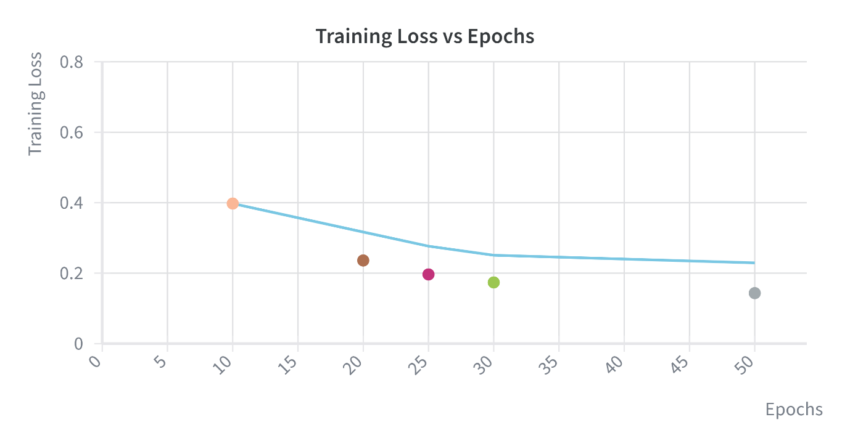
Figure: Training Loss vs Epoch
Conclusion: More epochs improve training accuracy, but with diminishing returns and growing overfitting. Validation accuracy saturates around 20-25 epochs, so 20-25 epochs is the best trade-off between accuracy and training cost. The 50-epoch run gives the best test accuracy (85.93%), but only about 1.2 points above 25 epochs for approx. twice the training time.
Learning Rate Variations:
Convergence speed: LR = 0.001 converges best, training accuracy reaches 91.92% in 20 epochs. At 0.005 it drops to 81.51%, and at 0.01 to only 71.06%. Higher learning rates did not speed up convergence here. They made training unstable, so the model had not settled even after 20 epochs.
Performance: Validation accuracy falls from 85.4% (0.001) to 79.34% (0.005) and 71.56% (0.01). Testing accuracy follows the same trend as 84.42%, 79.03%, 74.11%. Going from 0.001 to 0.01 costs about 10 points of test accuracy.
Epochs and Batch Size: Epochs is fixed to 20 and batch size if fixed at 128.
Comparison Table for Learning Rate
Sno | Activation | Optimizer | Learning Rate | Epochs | Batch Size | Training Accuracy (%) | Validation Accuracy (%) | Testing Accuracy (%)
1 | SiLU | NAdam | 0.001 | 20 | 128 | 91.92 | 85.4 | 84.42
2 | SiLU | NAdam | 0.005 | 20 | 128 | 81.51 | 79.34 | 79.03
3 | SiLU | NAdam | 0.01 | 20 | 128 | 71.06 | 71.56 | 74.11
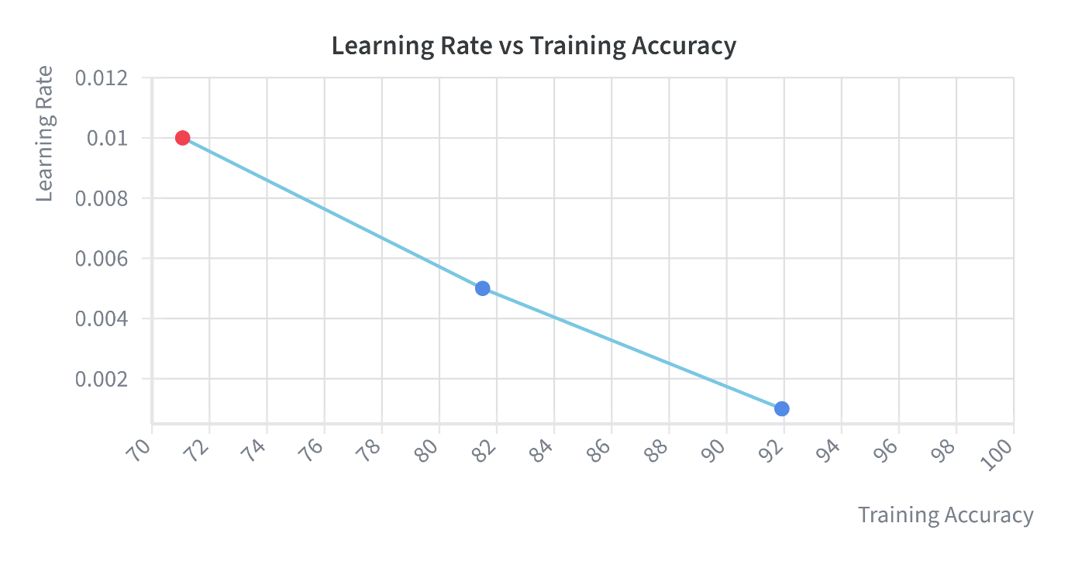
Figure: Learning Rate vs Training Accuracy
Conclusion
Learning rate has a strong effect. 0.001 is the best (91.92% train, 85.4% validation, 84.42% test). Accuracy decreases steadily as the rate increases to 0.005 and 0.01, because of unstable training and underfitting. Rates at or below 0.001 (for example 0.0005) could be tested next, though they would likely need more epochs to converge.

Batch Size Variation
Convergence speed: Training accuracy increases with batch size: 88.06% (32), 90.30% (64), 91.80% (128). With a fixed 20 epochs, the larger batch gave the better fit. A batch of 32 makes more updates per epoch, but they are noisier, so the model had not settled as well by epoch 20.
Performance: Validation accuracy rises from 83.96% to 85.02% and 85.3%. Testing accuracy follows as 83.44%, 84.06%, 84.13%. The gain from 32 to 64 is about 0.6 points, while 64 to 128 adds only 0.07, so the improvement saturates beyond 64.
Epochs and Learning Rate: Epochs are fixed at 20 and learning rate is fixed at 0.001.
Comparison Table for Batch Size
Sno | Activation | Optimizer | Batch Size | Epochs | Learning Rate | Training Accuracy (%) | Validation Accuracy (%) | Testing Accuracy (%)
1 | SiLU | NAdam | 32 | 20 | 0.001 | 88.06 | 83.96 | 83.44
2 | SiLU | NAdam | 64 | 20 | 0.001 | 90.30 | 85.02 | 84.06
3 | SiLU | NAdam | 128 | 20 | 0.001 | 91.80 | 85.3 | 84.13

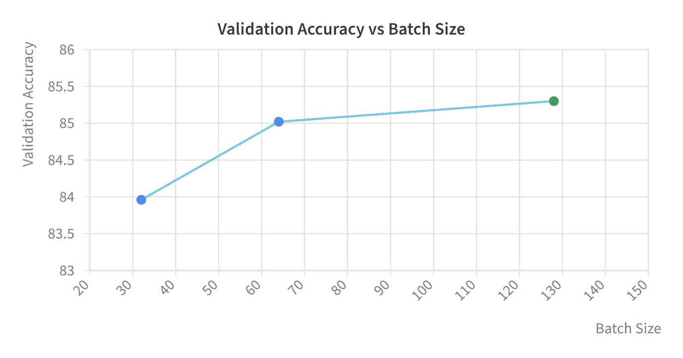
Figure: Validation Accuracy vs Batch Size
Conclusion
Batch size has a modest effect compared with learning rate. 128 gives the best accuracy (91.80% train, 85.3% validation, 84.13% test), but 64 achieves nearly the same test accuracy (84.06%) with a smaller generalization gap. Batch 32 performed worst at 20 epochs, likely needing more epochs to catch up. 64 or 128 is the best choice, with 128 preferred when training speed matters.

Question 3 a) Provide the W&B parallel-coordinate plot that shows which configuration achieves what accuracy.
Ans.
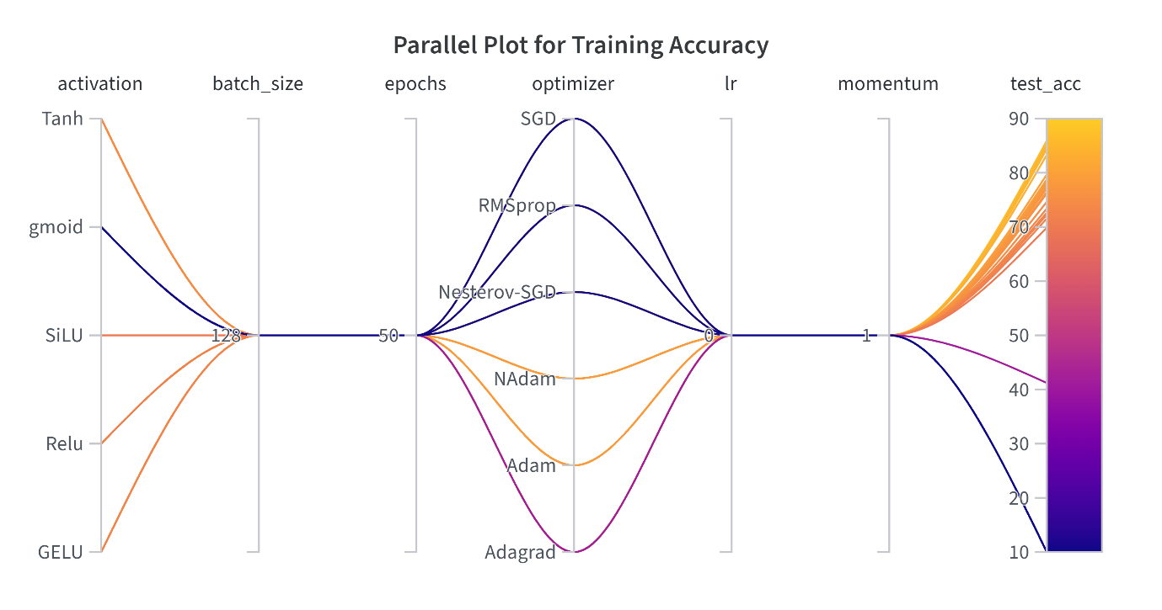
Figure: W&B parallel-coordinate plot for activation, epochs, learning rate(lr), momentum, optimizer & training accuracy(train_acc)

b) Provide the validation accuracy vs. step (scatter) plot.
Ans.
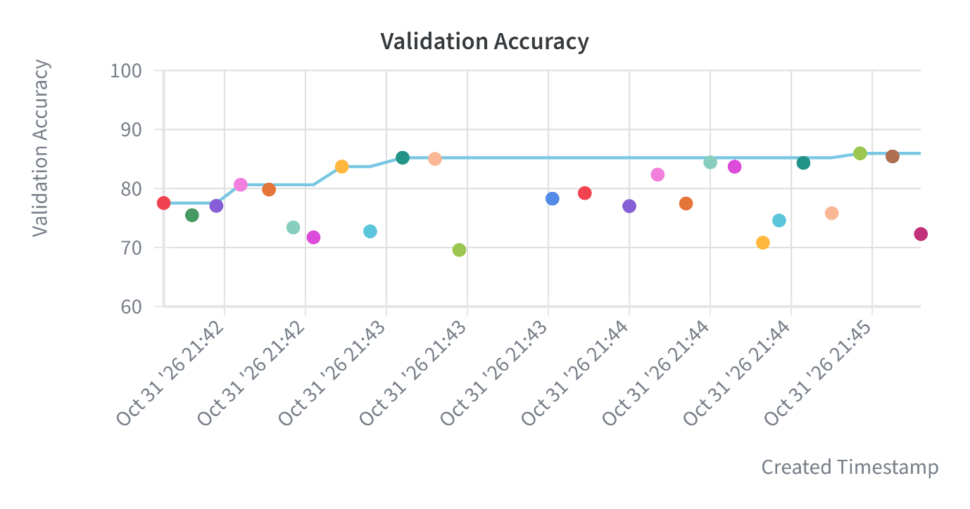
Figure: Validation Accuracy Plot

c) Provide the plots for training loss, training accuracy, validation loss, and validation accuracy respectively.
Ans.
- Training Loss Plot
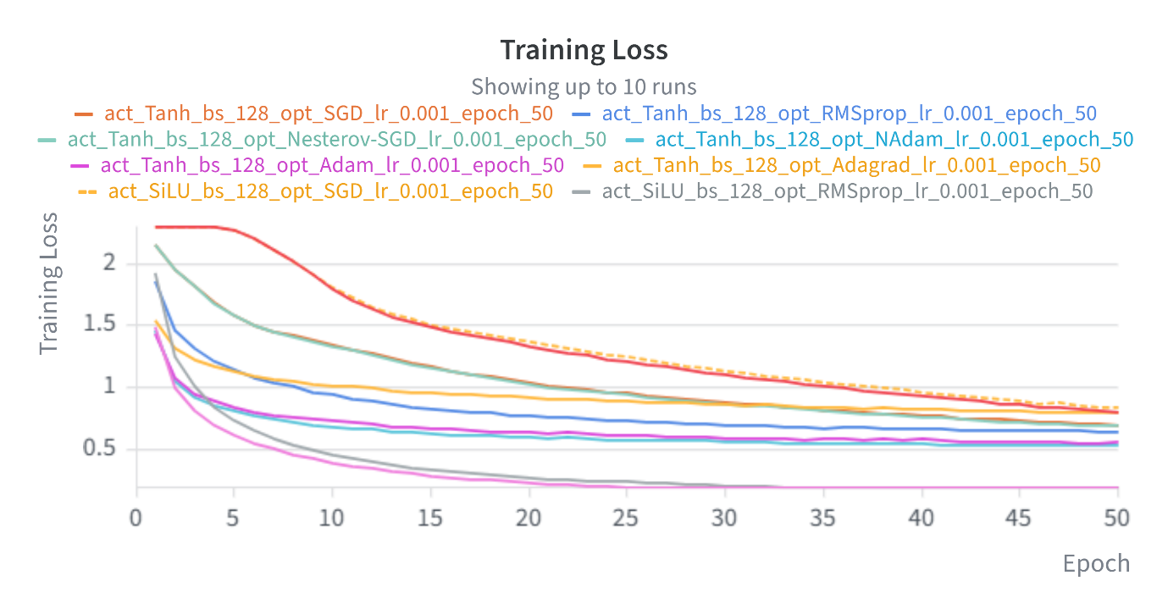
Figure: Training Loss

- Training Accuracy Plot
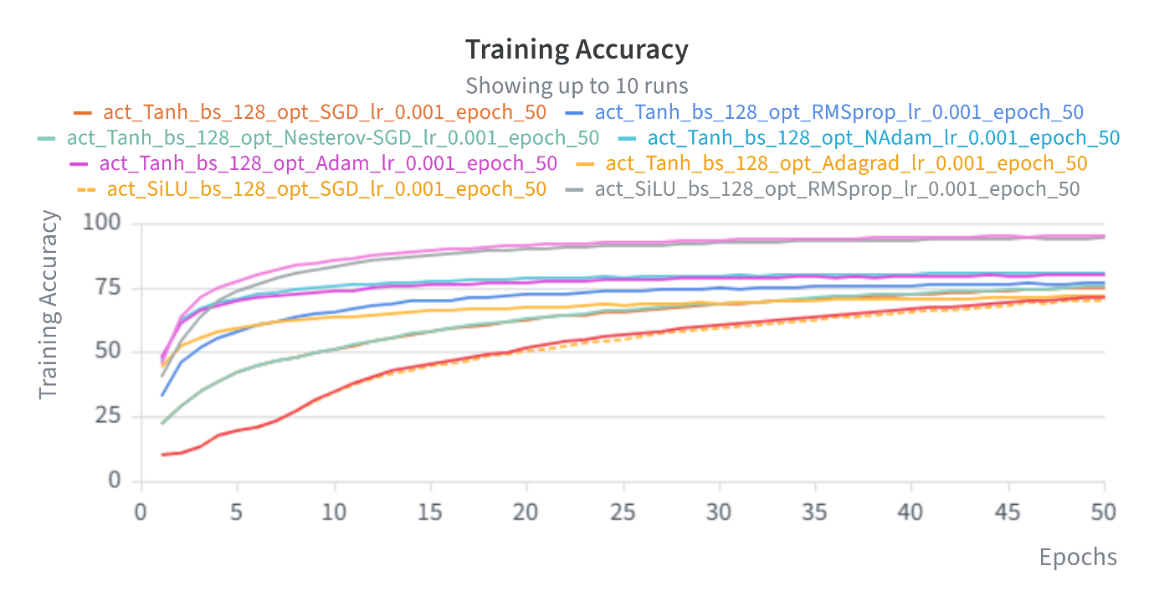
Figure: Training Accuracy

- Validation Accuracy Plot
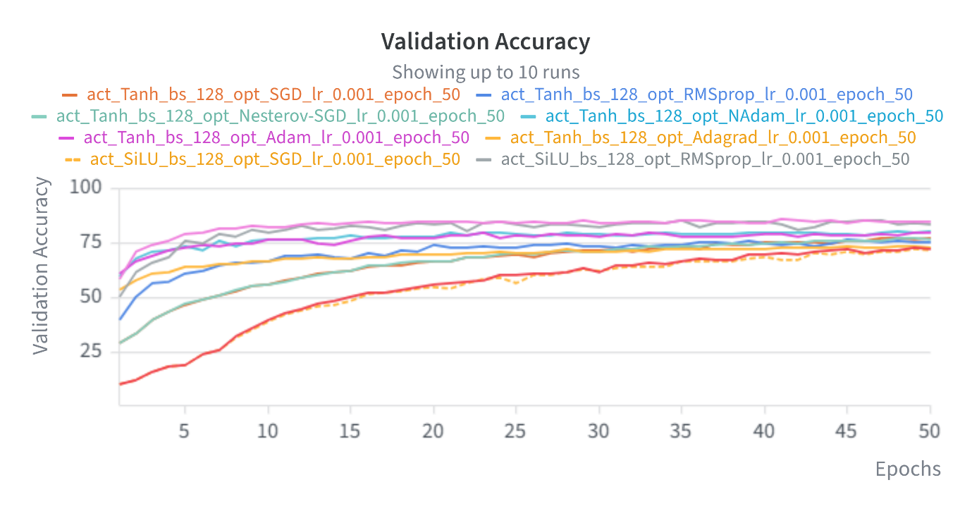
Figure: Validation Accuracy

- Validation Loss Plot
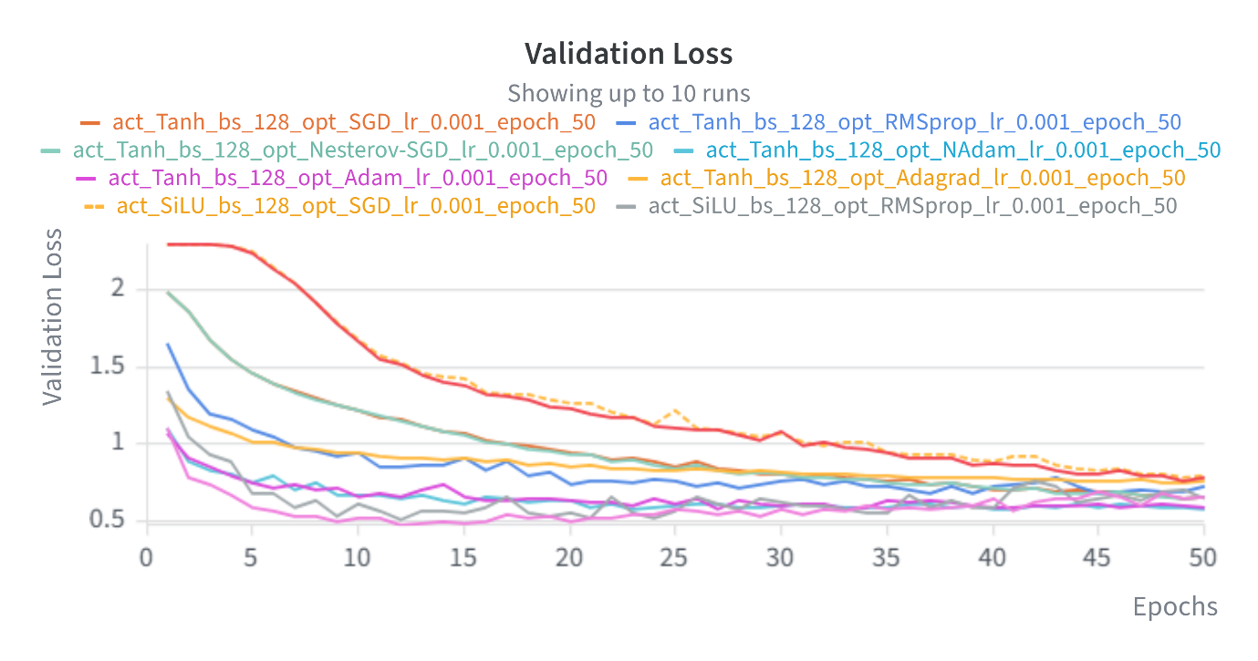
Figure: Validation Loss

Question 4. Based on the W&B parallel plot, provide the configuration that achieved the best validation accuracy. Do not list multiple configurations. The configuration mentioned here will be verified by re-running your model. Ensure that this configuration indeed reproduces the reported best accuracy.

Ans. Model with best validation accuracy based on parallel plot are given below

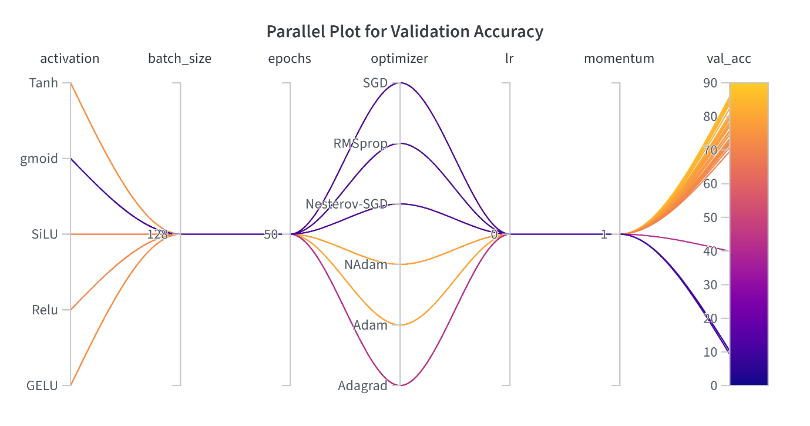

Figure: Parallel Plot for Validation Accuracy

Best validation accuracy is achieved as 86.02% with following mentioned hyperparameters:

Sno | Hyperparameter | Configuration
1 | Activation | GELU
2 | Optimizer | NAdam
3 | Epochs | 50
4 | Batch Size | 128
5 | Learning Rate | 0.001
6 | Momentum | 0.9
7 | Seed | 22
8 | Training Accuracy | 95.91 %
9 | Training Loss | 0.12
10 | Validation Accuracy | 86.02 %
11 | Validation Loss | 0.57
12 | Test Accuracy | 85.1 %
13 | Test Loss | 0.58

To execute and re-verify Validation Accuracy and Loss run on terminal “python main.py” and select Option 1 to run it on cifar10 dataset model.
Note: “cifar-10-batches-py”, “Models” folder and “VGG6.py”, “testModel.py” should be at location as of main.py.
Question 5.a) Provide clean, modular, and well-commented code with clear separation of training, evaluation.

Ans. Code files are as follows
Sno | File name | Description
1 | main.py | Contains all start configurations
2 | VGG6.py | Code for VGG6 architecture and its configuration
3 | testModel.py | Code to test best accuracy model
4 | Images (Directory) | Directory to contain all images which needs to be tested/validated
5 | Models (Directory) | Directory to contain best validation accuracy model

b) Include a README with exact commands, environment details, and dependency versions. Also include seed configuration.

Ans. README file is included into the git repo along with the code which has commands to execute this code.

Install all required dependencies mentioned in the README file.

To run code
Execute Command: python main.py
Then select appropriate choice of operation to be executed.
Choice 1: Evaluate Model for Best Validation Accuracy
Choice 2: To try GELU NAdam Model put images inside Images folder (some files are already present) at same location of main.py and then continue.
Choice 3: Train Validate and Test Model your choice.
Choice 4: Exit

Environment Details and Dependency versions:
Sno. | Items | Details
1 | Operating System | Windows 11 (Offline) / Google Colab (Online)
2 | Language | Python 3.11.4
3 | Framework | PyTorch 2.x
4 | Hardware | CPU / GPU (T4 from Google Colab)
5 | IDE / Platform | Google Colab, Pycharm (Local Computer)
6 | Plots | Weight and Biases (wandb)
7 | Python Libs with version
  torch: | 2.4.1
  torchvision: | 0.19.1
  wandb: | 0.31.0
  numpy: | 2.4.6

Seed: Seed value is selected as 22

c) Upload the trained model to the GitHub repository and provide the GitHub repository link inside the pdf.

Ans. Code can be viewed using https://github.com/cs25m525/DeepLearning_Assignment_01

Git Clone Link: https://github.com/cs25m525/DeepLearning_Assignment_01.git

